Module6 Activity Paper
1. Implement the perceptron using Python as specified in the template.
The perceptron was implemented in Python according to the structure provided in the Module Six Activity starter code. The perceptron calculates a weighted sum by multiplying each input value by its corresponding weight and adding the products together. A step activation function is then used to convert the weighted sum into a binary prediction. The perceptron returns 1 when the weighted sum is greater than zero and returns 0 otherwise.
The training function was also completed so that the perceptron could learn from the training data. The weights are initially set to zero. For each training example, the model produces a prediction and compares it with the expected output. When the prediction is incorrect, the weights are adjusted using the learning rate, prediction error, and corresponding input values. The process is repeated for the specified number of epochs. The professor's starter code provides this structure and requires the weighted-sum calculation and weight-update portions to be completed.
This implementation represents the basic idea of a perceptron as a linear classification model. A perceptron makes predictions using a linear decision function and updates its parameters when training examples are misclassified (scikit-learn developers, n.d.).
2. Train the perceptron manually using the values provided in the template.
The perceptron was trained manually using the input values, expected outputs, and weight values provided in the Module Six Activity template. For each training example, the input values were combined with the corresponding weights to calculate the perceptron's weighted sum. The step activation function was then applied to determine whether the predicted output was 0 or 1.
The manual training process required adjusting the weights so that the predicted outputs matched the expected outputs for the training examples. The results of the manual calculations were recorded in the tables provided in the assignment template. These results were then used to determine which functions could be learned by a single perceptron and which function could not be learned.
The manual-training experiment demonstrates that the success of a perceptron depends on whether the relationship between the inputs and outputs can be represented by a linear decision boundary. This observation is important for comparing the manually trained perceptron with the algorithmically trained perceptron later in the assignment.
function1_training_data = [
([1, 0, 1], 0),
([0, 1, 1], 0),
([0, 0, 1], 0),
([1, 1, 1], 1)
]
function2_training_data = [
([1, 0, 1], 1),
([0, 1, 1], 1),
([0, 0, 1], 0),
([1, 1, 1], 1)
]
function3_training_data = [
([1, 0, 1], 1),
([0, 1, 1], 1),
([0, 0, 1], 0),
([1, 1, 1], 0)
]
3. Document the results of manual training
a. Explain the results of manually training the perceptron.
The manual training results demonstrate that a single perceptron can learn some functions successfully but cannot learn every type of relationship. Function 1 and Function 2 contain input-output relationships that can be represented using a linear decision boundary. Therefore, appropriate weights can be selected so that the perceptron produces the required outputs for the training examples.
Function 3 produces a different result. Its training data contains two positive cases, [1, 0, 1] and [0, 1, 1], and two negative cases, [0, 0, 1] and [1, 1, 1]. This pattern represents an XOR-type relationship. The positive and negative cases cannot be separated using a single linear decision boundary. Consequently, a single perceptron cannot correctly classify every example in Function 3.
The manual training experiment therefore shows that successful perceptron training depends on the structure of the data. When the relationship is linearly separable, a single perceptron can learn the required classification. When the relationship is not linearly separable, changing the weights of a single perceptron is not sufficient to produce correct predictions for every training example. The training data for the three functions is provided in the starter code.
b. Which of the three functions is not trainable? Why?
Function 3 is not trainable using a single-layer perceptron. Function 3 represents an XOR-type relationship in which the output is 1 when exactly one of the first two input values is 1 and is 0 when the two input values are the same. A single perceptron produces a linear decision boundary, so it cannot separate these four cases correctly.
The inability to train Function 3 is therefore a limitation of the single perceptron model rather than a programming error. This result also explains why the assignment later uses an MLPClassifier with a hidden layer to solve Function 3. The purpose of adding hidden nodes is to allow the network to represent relationships that cannot be represented by a single linear decision boundary.
4. Write an algorithm to train the perceptron.
The perceptron training algorithm begins by initializing all weights to zero. The training data are then processed one instance at a time during each epoch. For each instance, the algorithm calculates the weighted sum of the input values and uses the perceptron function to produce a predicted output of either 0 or 1.
The predicted output is compared with the expected output to calculate the prediction error. The error is then used to update each weight according to the learning rate and the corresponding input value. The process is repeated for all training instances and for the specified number of epochs. In the provided implementation, the default learning rate is 0.1 and the algorithm trains for 100 epochs.
The algorithm can be summarized as follows:
- Initialize all weights to zero.
- Select a training instance and its expected output.
- Calculate the predicted output using the current weights.
- Calculate the error as expected output minus predicted output.
- Update each weight using the learning rate, error, and corresponding input value.
- Repeat Steps 2 through 5 for every training instance.
- Repeat the process for the specified number of epochs.
- Return the final set of weights.
The weight-update rule used by the algorithm is:
Weight = Weight + Learning Rate *(Error) * (Input)
This process allows the perceptron to gradually improve its predictions for functions that can be represented by a linear decision boundary. The same algorithm was then applied to Functions 1, 2, and 3 so that the results could be compared.
5. Run the algorithm for all three functions
a. Describe your algorithm.
The perceptron training algorithm was applied to all three functions using the same training procedure. The weights were initialized to zero, and each training instance was processed sequentially. For each instance, the algorithm calculated the perceptron's predicted output and compared it with the expected output. The difference between the expected and predicted values was used as the error.
When an error occurred, each weight was updated using the learning rate, error, and corresponding input value. The algorithm repeated this process for all training instances and continued for 100 epochs. The final weights produced by the algorithm were then used to classify the training instances for Functions 1, 2, and 3.
This procedure provided a consistent way to evaluate whether the three functions could be learned by a single perceptron. The training algorithm follows the structure provided in the professor's starter code, including the zero-weight initialization, learning rate of 0.1, and 100 training epochs.
b. Provide the weights your algorithm generated for each function.
The algorithm generated the following final weights after training:
Function | Final Weights
Function 1 | [0.1, 0.2, -0.2]
Function 2 | [0.1, 0.1, 0.0]
Function 3 | [0.0, -0.1, -0.1]

The results show that the algorithm successfully produced a set of weights for Functions 1 and 2 that classified all four training instances correctly. For Function 3, the generated weights were not sufficient to classify all four training instances correctly.
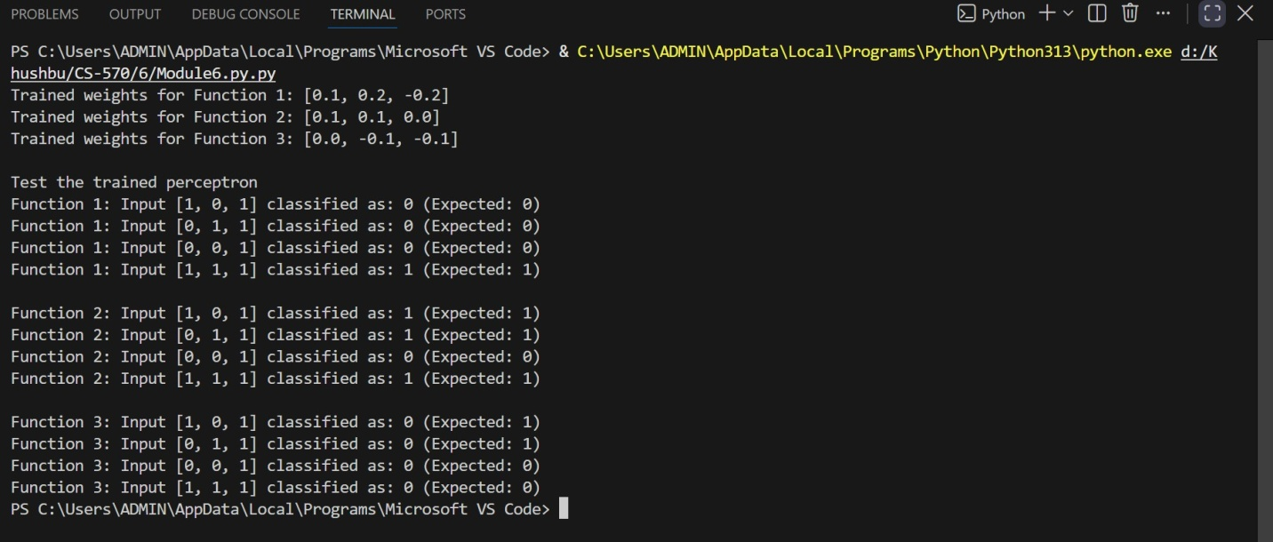
c. Did your algorithm work for Function 3?
No. The algorithm did not successfully train the single perceptron to classify Function 3 correctly. The final weights generated for Function 3 were [0.0, -0.1, -0.1]. Using these weights, the perceptron produced the following results:
Input | Expected Output | Predicted Output
[1, 0, 1] | 1 | 0
[0, 1, 1] | 1 | 0
[0, 0, 1] | 0 | 0
[1, 1, 1] | 0 | 0

d. Are the weights you found manually the same as the weights your algorithm found?
The Python training algorithm generated the following weights: [0.1, 0.2, -0.2] for Function 1, [0.1, 0.1, 0.0] for Function 2, and [0.0, -0.1, -0.1] for Function 3. The program output shows that the generated weights successfully classified all four training examples for Functions 1 and 2, while Function 3 was not classified correctly for all four examples.
Because separate numerical manual weights were not provided in the assignment materials, an exact numerical comparison between manually selected weights and algorithm-generated weights cannot be made. However, the training results show that the algorithm successfully learned Functions 1 and 2 and encountered the same fundamental limitation with Function 3. Therefore, the important comparison is the classification performance of the two training approaches rather than the exact numerical values of the weights.
e. Compare the training performance of the manual and algorithmic methods.
The manual and algorithmic training methods demonstrated similar behavior with respect to the limitations of a single perceptron. Functions 1 and 2 could be successfully represented by a single perceptron, while Function 3 could not be completely learned.
The main difference is that manual training requires the user to select and adjust weights directly, whereas the algorithm automatically calculates the prediction error and applies the weight-update rule repeatedly across the training data. The algorithm therefore provides a systematic and repeatable way to train the perceptron rather than requiring the weights to be adjusted manually.
The algorithm successfully classified all training examples for Functions 1 and 2. For Function 3, it produced incorrect classifications for two of the four examples, confirming that additional weight updates cannot make a single linear perceptron solve the XOR-type relationship. The results therefore show that the limitation comes from the model structure rather than from the particular training procedure.
Overall, the algorithmic method provided a more systematic and repeatable way to find suitable weights for the linearly separable functions, while both methods demonstrated the same fundamental limitation for Function 3.
6. Train an MLPClassifier on Function 3 as specified in the template.
After training the single-layer perceptron, an MLPClassifier was used to determine whether a multilayer neural network could learn Function 3. The MLPClassifier was trained using the four Function 3 training instances provided in the assignment. The model was configured with different solvers, activation functions, and numbers of hidden-layer nodes to evaluate how the network architecture and training settings affected the results.
The first successful configuration used the lbfgs solver, the logistic activation function, and 2 hidden-layer nodes. The network contained three layers in total: the input layer, one hidden layer containing 2 nodes, and the output layer. The model correctly classified all four Function 3 training instances, resulting in a successful classification result.
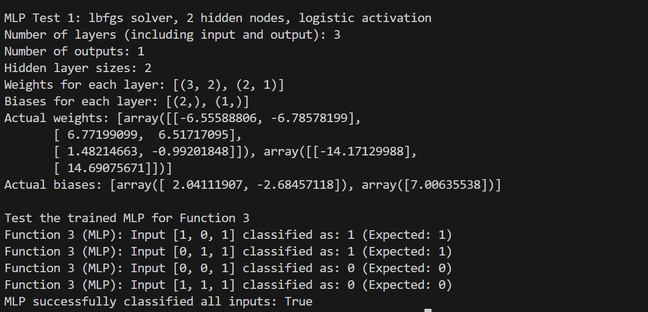
The second successful configuration used the adam solver, the relu activation function, and 5 hidden-layer nodes. This network also contained three layers and correctly classified all four Function 3 training instances. The model successfully learned the Function 3 relationship using this multilayer architecture.
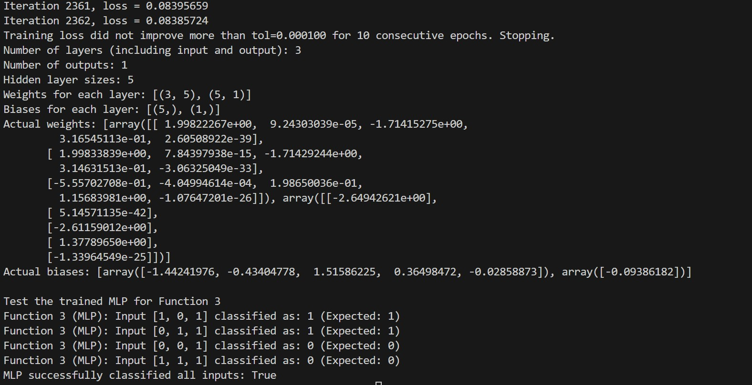
These results demonstrate that adding a hidden layer allows the neural network to learn Function 3 even though the single-layer perceptron could not. The professor's starter code specifically provides the MLPClassifier function for testing Function 3 with different solver, hidden-layer-node, and activation settings.
7) Explain the results of your experiments
a) Which combinations worked and which did not?
Two MLPClassifier configurations were tested on Function 3, and both configurations successfully classified all four training examples.
The first successful configuration used the lbfgs solver, the logistic activation function, and 2 hidden-layer nodes. The model correctly classified all four Function 3 inputs, so this combination was successful.
The second successful configuration used the adam solver, the relu activation function, and 5 hidden-layer nodes. This model also correctly classified all four Function 3 inputs, so this combination was successful.
Therefore, both configurations documented in this experiment worked successfully. In contrast, the single-layer perceptron used earlier was unable to learn Function 3 because of the nonlinear XOR-type relationship. The MLP provides hidden-layer processing that allows the network to model this relationship. The professor's starter code specifically provides the MLPClassifier function to test different solver, activation, and hidden-layer configurations on Function 3.
b) For each combination that worked, what were the final hyperparameters (solver, activation, and number of hidden layer nodes) and parameters (weights and biases)?
Two combinations successfully trained the MLPClassifier on Function 3.
Combination 1:
- Solver: lbfgs
- Activation function: logistic
- Hidden-layer nodes: 2
- Total layers: 3
- Number of outputs: 1
The learned weight matrices had shapes of (3, 2) and (2, 1), corresponding to the connections from the input layer to the hidden layer and from the hidden layer to the output layer. The learned bias vectors had shapes of (2,) and (1,). The actual numerical weights and biases are shown in Screenshot 2.
Combination 2:
- Solver: adam
- Activation function: relu
- Hidden-layer nodes: 5
- Total layers: 3
- Number of outputs: 1
The learned weight matrices had shapes of (3, 5) and (5, 1), and the bias vectors had shapes of (5,) and (1,). The actual numerical weights and biases are shown in Screenshot 3.
The MLPClassifier stores the learned connection weights in its coefs_ attribute and the learned bias values in its intercepts_ attribute. The assignment code was extended to print these numerical values so that the required model parameters could be documented.
c) Which combination requires the fewest nodes in the hidden layer?
The lbfgs solver with the logistic activation function required the fewest hidden-layer nodes among the successful configurations tested. It successfully classified Function 3 using only 2 hidden nodes, whereas the adam and relu configuration used 5 hidden nodes.
Therefore, the successful configuration requiring the fewest hidden nodes were:
Solver: lbfgs
Activation: logistic
Hidden-layer nodes: 2
This result shows that increasing the number of hidden nodes is not always necessary for a particular problem. The combination of the solver, activation function, and network size influences how effectively the model can learn the underlying relationship.
d) For the combinations that would not train, explain why?
The two configurations documented in the final experiments both successfully classified all four Function 3 training examples. Therefore, there is no unsuccessful final MLP combination among the two configurations reported in this assignment.
During repeated executions, however, the MLP training results could vary. The professor's MLPClassifier code does not specify a fixed random_state, so the network can begin with different randomly initialized weights on different runs. As a result, the optimization process may follow a different path, and the number of iterations, final loss, and classification result can vary between executions.
This observation demonstrates that neural-network training can be sensitive to initialization and tuning. It also reinforces the importance of evaluating the actual training results rather than assuming that a particular configuration will always produce identical results. The assignment asks students to explain how tuning affects outcomes, making this an important observation from the experiment.
8. Explain what you learned about how networks learn and how tuning affects outcomes.
The experiments showed that a single perceptron can learn linearly separable functions, but it cannot learn the XOR-type Function 3. The MLP successfully learned Function 3 by adding a hidden layer and using different solver and activation settings.
The two successful MLP configurations were lbfgs with logistic activation and 2 hidden nodes, and adam with relu activation and 5 hidden nodes. The results also showed that neural-network training can vary between runs because different initial weights can lead to different training outcomes. Therefore, selecting appropriate network settings and evaluating the results are important when training neural networks.
Conclusion
This activity demonstrated the differences between a single perceptron and a multilayer perceptron. The single perceptron successfully learned the linearly separable functions but was unable to learn Function 3, which represents an XOR-type relationship. The MLP successfully learned Function 3 using different combinations of solvers, activation functions, and hidden-layer sizes. The experiments also showed that neural-network performance can vary depending on initialization and training settings. Overall, the activity demonstrated the importance of selecting an appropriate network structure and tuning the training parameters for the problem being solved.
References
scikit-learn developers. (n.d.). MLPClassifier. Scikit-learn. https://scikit-learn.org/stable/modules/generated/sklearn.neural_network.MLPClassifier.html
scikit-learn developers. (n.d.). Perceptron. Scikit-learn. https://scikit-learn.org/stable/modules/generated/sklearn.linear_model.Perceptron.html
scikit-learn developers. (n.d.). Neural network models (supervised). Scikit-learn. https://scikit-learn.org/stable/modules/neural_networks_supervised.html

